Reducing Waste Discharge into the Environment through the Regeneration of Spent Methyldiethanolamine Solutions

Shokhzod X. Azamov*, Nargisa A. Igamkulova, Sherzod Sh. Mengliyev, Saidjon A. Joniboyev, Tolib B. Turaev, Mavluda A. Mirzaahmedova

Tashkent Institute of Chemical Technology, Tashkent, Uzbekistan
*Corresponding author: azamovshaxzod@gmail.com

Aqueous methyldiethanolamine (MDEA) solutions used in natural gas sweetening gradually lose their working properties during prolonged industrial service because of thermal stress, oxidative transformations, interaction with acidic gas components, and accumulation of heat-stable salts, resinous substances, and metal-containing impurities. This study evaluates regeneration of spent 30 wt.% MDEA solutions as a means of restoring solvent performance and reducing waste discharge into the environment. Regeneration was carried out under laboratory conditions by vacuum distillation at 2.0×10³ Pa and 160–185 °C, followed by liquid-liquid extraction using chloroform and ethyl acetate. Fresh, spent, and regenerated samples were analyzed by physicochemical testing, FTIR, Raman spectroscopy, GC-MS, and spectral analysis of inorganic contaminants. After regeneration, heat-stable salts decreased from 2,218 to 300 ppm, bound amine from 6.85 to 0.20 %, viscosity from 3.6 to 2.78 cP, density from 1.29 to 1.018 g/cm³, and foam height from 1.9 to 1.1 cm. GC-MS analysis confirmed MDEA recovery of about 60 % after chloroform extraction and up to 78 % after ethyl acetate extraction. The proposed approach restores spent solvent, reduces solvent losses and waste discharge, and improves the operational and environmental performance of natural gas sweetening systems.
Keywords: methyldiethanolamine; natural gas sweetening; solvent degradation; solvent regeneration; heat-stable salts; waste reduction; amine purification
Introduction
Natural gas is one of the main feedstocks for the energy and chemical industries, but its industrial use requires prior removal of acidic and toxic components, mainly hydrogen sulfide, carbon dioxide, and mercaptans. These impurities reduce gas quality, intensify corrosion, promote deposit and heat-stable salt formation, and impair the operational stability of gas-processing units. Therefore, acid gas removal is both a technological and an environmental requirement in modern gas-processing practice (Abotaleb et al., 2022).
Aqueous methyldiethanolamine (MDEA) solutions are widely used for industrial gas sweetening because of their favorable selectivity, relatively low regeneration energy demand, and broad applicability. However, long-term solvent performance depends strongly on solvent stability, process conditions, and impurity control. Mohajeri et al. (2024) showed that optimal plant operation can reduce energy consumption, while Faqih et al. (2024) emphasized the importance of solvent composition for reliable acid gas removal.
During prolonged industrial service, MDEA solutions gradually lose their working properties because of thermal stress, oxidative transformations, chemical interaction with acidic gas components, and accumulation of degradation products. As a result, the solvent exhibits lower absorption efficiency, higher viscosity, stronger foaming tendency, and greater susceptibility to corrosion and fouling. Panahi et al. (2020) reported that heat-stable acids intensify corrosion in activated MDEA systems. Shahouni et al. (2024) demonstrated that degradation-related compounds and suspended impurities contribute significantly to foaming and operational instability.
Spent amine degradation also creates an environmental burden associated with disposal of contaminated solvent streams. For this reason, regeneration of spent solvents is increasingly regarded as a resource-efficient and environmentally sound approach. Shirokikh et al. (2023) demonstrated the feasibility of removing heat-stable salts from degraded amine solvents, while Wishnuwardana et al. (2025) highlighted the need for more sustainable amine management strategies in acid gas removal units.
Recent studies have confirmed the importance of process optimization, solvent selection, and solvent reuse in gas sweetening systems. Chew et al. (2022), Esmaeili et al. (2023), and Yehya et al. (2025) showed that simulation-based approaches can improve process performance and reduce energy demand. Studies published in Chemical Engineering Transactions further demonstrated the relevance of MDEA-based blended solvents for gas treatment applications (Etoumi et al., 2021; Guo et al., 2021; Mailhol and Bouallou, 2021). Regional studies also confirmed that regeneration and recycling of ethanolamine solvents can reduce environmental impact and improve solvent reuse potential (Turaev et al., 2024; Igamqulova et al., 2023; Igamkulova et al., 2023).
Although recent studies have addressed solvent degradation and amine purification, the combined assessment of spent MDEA regeneration in terms of solvent recovery, restoration of solvent properties, and reduction of environmental waste discharge remains insufficiently explored. Therefore, the present study evaluates regeneration of spent 30 wt.% MDEA solutions used in natural gas sweetening under laboratory conditions.
Materials and Methods
The study was carried out using a 30 wt.% aqueous methyldiethanolamine (MDEA) solution withdrawn after prolonged service from an industrial natural gas sweetening unit. A fresh 30 wt.% MDEA solution was used as a reference sample for comparative evaluation. Chloroform and ethyl acetate were used as extractants during the regeneration stage.
Regeneration of the spent amine solution was performed by vacuum distillation followed by liquid-liquid extraction. In the first stage, 200 mL of spent 30 wt.% MDEA solution was heated under reduced pressure (2.0×10³ Pa, 160–185 °C). Under these conditions, an amine-containing distillate was separated from the still-bottom residue containing degradation products and heat-stable salts. The process yielded three fractions: amine-containing distillate, aqueous condensate, and still-bottom residue. The total loss during laboratory-scale vacuum distillation did not exceed 1.6 wt.%. The procedure was adapted from reported methods for purification of ethanolamine solutions (Alekseev et al., 1999; Shpeleva, 2011).
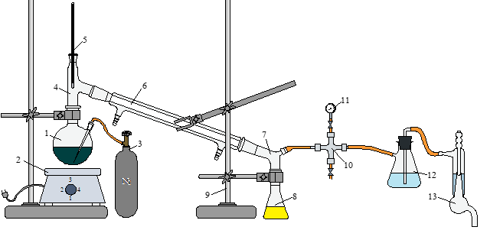 | Figure 1. Schematic diagram of the laboratory unit used for vacuum distillation of spent MDEA solution.  1, 8, 12 – flasks; 2 – electric heater; 3 – nitrogen cylinder; 4, 7 – adapters; 5 – thermometer; 6 – condenser; 9 – stand; 10 – connector; 11 – barometer; 13 – vacuum pump.
In the second stage, the obtained liquid fraction and still-bottom residue were treated separately by liquid-liquid extraction. Chloroform and ethyl acetate were used as extractants at a 1:1 volume ratio. The mixtures were processed in a separatory funnel until phase separation was achieved, after which the extract-containing fractions were collected and concentrated under reduced pressure.
Fresh, spent, and regenerated samples were comparatively evaluated in terms of free amine content, bound amine content, heat-stable salts, mechanical impurities, pH, viscosity, density, foam height, and foam stability time.
Structural and compositional changes in fresh, spent, and regenerated MDEA solutions were studied by FTIR spectroscopy, Raman spectroscopy, gas chromatography-mass spectrometry (GC-MS), and spectral analysis of inorganic impurities. Raman spectra were recorded using a Renishaw InVia Raman spectrometer with a laser wavelength of 785 nm, while FTIR spectra were obtained using a Fourier-transform infrared spectrometer. FTIR spectra were interpreted using reported approaches for petroleum-related and organic systems (Ivanova et al., 2008; Ivanova et al., 2010).
GC-MS analysis was performed to determine the composition of regenerated fractions and to confirm the presence and relative recovery of methyldiethanolamine. Compound identification was carried out using the NIST 2017 spectral database. According to the chromatographic results, the MDEA content in the chloroform-treated fraction was about 60 %, whereas the corresponding value for the ethyl acetate-treated fraction reached approximately 78 %.
The distribution of inorganic and metal-containing species in the fresh amine, spent amine, regenerated fractions, and still-bottom residue was additionally evaluated by spectral analysis. The results showed the presence of sulfur-, chlorine-, potassium-, calcium-, chromium-, manganese-, silicon-, and iron-containing species, together with smaller amounts of copper, nickel, and zinc. Comparative evaluation demonstrated that the main portion of heavy metals was concentrated in the still-bottom residue, while their content in the regenerated amine fraction was substantially lower.
Results and Discussion
Changes in physicochemical properties after regeneration
The comparative evaluation of spent and regenerated 30 wt.% MDEA solutions showed that the proposed treatment significantly improved the physicochemical characteristics of the working absorbent. As shown in Table 1, regeneration reduced the content of bound amine, heat-stable salts, and mechanical impurities, while improving pH, viscosity, density, and foaming behaviour. These changes indicate that the treated solution regained the key properties required for further application in natural gas sweetening systems.
The most important improvements were observed for bound amine and heat-stable salts. Bound amine decreased from 6.85 to 0.20 %, while heat-stable salts decreased from 2,218 to 300 ppm. This confirms effective removal of the compounds responsible for solvent deactivation, corrosion enhancement, and unstable process behaviour. Similar observations were reported by Panahi et al. (2020), who showed that heat-stable acids intensify corrosion processes in amine systems.
A positive trend was also observed for the main operational properties of the solvent. Viscosity decreased from 3.6 to 2.78 cP, density from 1.29 to 1.018 g/cm3, and foam height from 1.9 to 1.1 cm. In practical terms, these changes improve solvent circulation, reduce excessive foaming, and contribute to more stable absorber operation. Shahouni et al. (2024) also emphasized that degradation products and suspended impurities are among the major causes of foaming and instability in amine-based systems.
Table 1: Comparison of the physicochemical properties of spent and regenerated 30 wt.% MDEA solutions
No. | Parameter | Spent 30 wt.% MDEA solution | Regenerated MDEA solution
1 | Free alkanolamine, % | 23.15 | 23.15
2 | Bound alkanolamine, % | 6.85 | 0.20
3 | Heat-stable salts, ppm | 2,218 | 300
4 | Mechanical impurities, mg/L | 758–1,038 | 0.3–0.8
5 | H₂S, mg/m³ | 15–18 | 15–18
6 | CO₂, % | 2.32 | 2.32
7 | pH | 9.1 | 10.3
8 | Viscosity, cP | 3.6 | 2.78
9 | Density, g/cm³ | 1.29 | 1.018
10 | Foam height, cm | 1.9 | 1.1
11 | Foam stability time, s | 19–22 | at least 15–17

As shown in Table 1, regeneration restored the principal working parameters of the solvent to values more suitable for industrial operation, particularly through lower heat-stable salt content, lower viscosity and foam height, reduced bound amine, and improved pH stability.
Spectroscopic evidence of degradation and purification
Spectroscopic analysis clearly revealed the difference between pure, spent, and regenerated MDEA samples. In the Raman spectra of untreated spent amine, the signal-to-noise ratio was significantly higher and the relative intensity of characteristic bands differed from those of the pure sample, indicating the presence of degradation-related compounds and foreign substances in the working solution. After purification, the spectral characteristics of the regenerated sample became much closer to those of fresh MDEA, confirming substantial removal of degradation products.
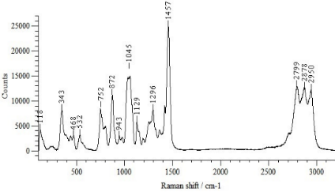 | 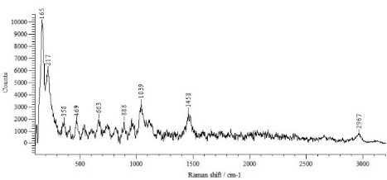
(a) pure MDEA | (b) spent MDEA
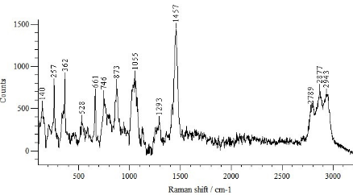
(c) regenerated MDEA.
Figure 2. Raman spectra of MDEA samples: (a) pure MDEA; (b) spent MDEA; (c) regenerated MDEA.
The Raman results show that the purification procedure removed a significant portion of the compounds responsible for solvent deterioration.
A similar trend was observed in the FTIR spectra. In particular, the broad O–H stretching region is located approximately in the 3,200–3,700 cm⁻¹ range, whereas the C–O stretching vibrations are mainly observed in the 1,000–1,150 cm⁻¹ region. Changes in these regions indicate modification of hydrogen bonding and oxygen-containing functional groups during prolonged solvent use and subsequent regeneration. The spent MDEA solution showed noticeable differences in the absorption regions corresponding to OH and C–O groups, indicating structural and compositional changes caused by prolonged industrial service. In the regenerated sample, the overall spectral profile became much closer to that of fresh MDEA, confirming the purification effect of the proposed treatment. At the same time, several additional bands remained visible in the regenerated sample, showing that complete restoration to the composition of fresh amine was not achieved, which is expected for regenerated industrial solvents.
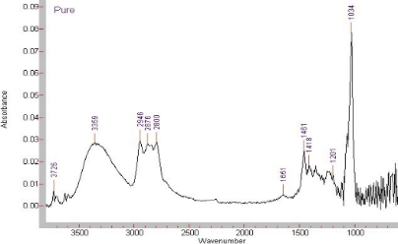 | 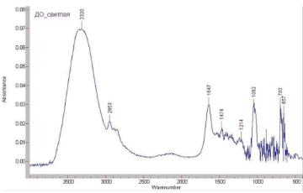
a) pure MDEA | (b) spent MDEA
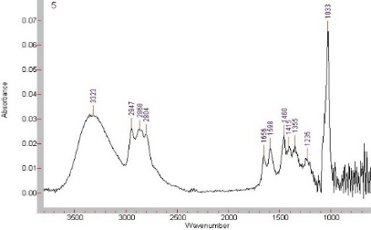.
(c) regenerated MDEA
Figure 3. FTIR spectra of MDEA samples: (a) pure MDEA; (b) spent MDEA; (c) regenerated MDEA
The peaks observed around 3,700 cm⁻¹ in Figure 3a may be attributed to weakly hydrogen-bonded or free O–H stretching vibrations associated with hydroxyl-containing species and trace water in the fresh MDEA solution.
Taken together, the Raman and FTIR results demonstrate that degradation of MDEA is accompanied by measurable structural changes, while regeneration removes a substantial fraction of the degradation-related compounds and restores the main spectral characteristics of the solvent.
GC-MS analysis of regenerated fractions
GC-MS analysis provided direct evidence of solvent recovery and allowed comparison of the extractants used in the study. The chromatographic data showed that MDEA remained the principal component in the regenerated fractions, and its relative amount depended strongly on the extraction solvent. In the chloroform-treated fraction, the MDEA content reached approximately 60 %, whereas in the ethyl acetate-treated fraction it increased to about 78 %.
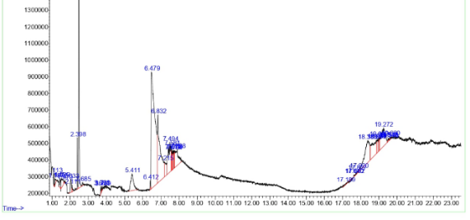 | 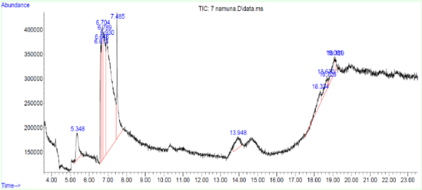
Figure 4. GC-MS chromatograms of regenerated MDEA fractions: (a) chloroform-treated fraction; (b) ethyl acetate-treated fraction.
These results indicate that ethyl acetate was more effective than chloroform in recovering the target amine under the selected conditions. At the same time, the chromatograms revealed the presence of low-boiling and high-boiling compounds, confirming that prolonged industrial operation leads to complex chemical transformation of the solvent. Thus, the chromatographic data verify both MDEA recovery and reduction of degradation-related compounds.
Distribution of inorganic and metal-containing impurities
An important outcome of the study was the redistribution of inorganic and metal-containing impurities among the obtained fractions. The spectral data showed that sulfur-, chlorine-, potassium-, calcium-, chromium-, manganese-, silicon-, and iron-containing species were present in the spent solution and were concentrated mainly in the still-bottom residue after regeneration. In contrast, the regenerated amine fraction contained substantially lower amounts of these components.
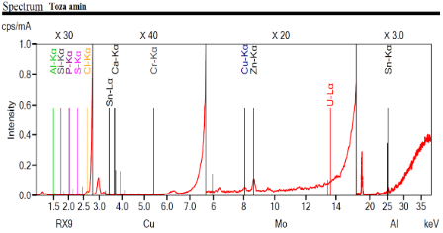 | 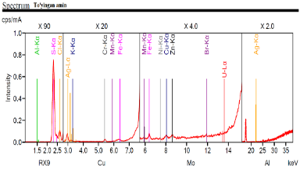 | 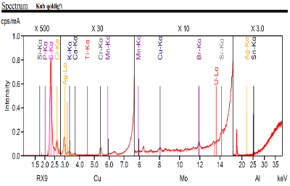
(a) fresh amine | (b) spent amine | (c) still-bottom residue
Figure 5. Spectral analysis of amine fractions: (a) fresh amine; (b) spent amine; (c) still-bottom residue
This result is important from both technological and environmental points of view. In technological terms, inorganic and metal-containing impurities intensify corrosion, contribute to fouling, and destabilize the solvent. In environmental terms, their concentration in the still-bottom residue means that the main hazardous impurity load is transferred into a smaller residual stream, which simplifies waste handling and reduces the amount of contaminated liquid phase.
The comparative analysis of heavy metals and industrial residue components confirmed this conclusion. The total amount of metals in the regenerated amine fraction was on average about 74 % lower than in the still-bottom residue, while for some elements, especially manganese and chromium, the reduction was even more pronounced.
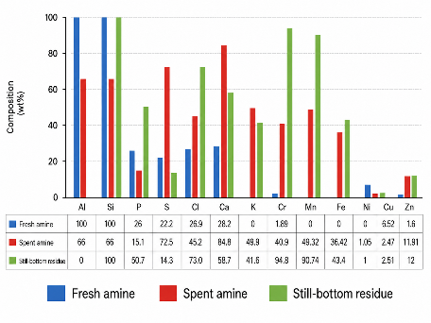 | 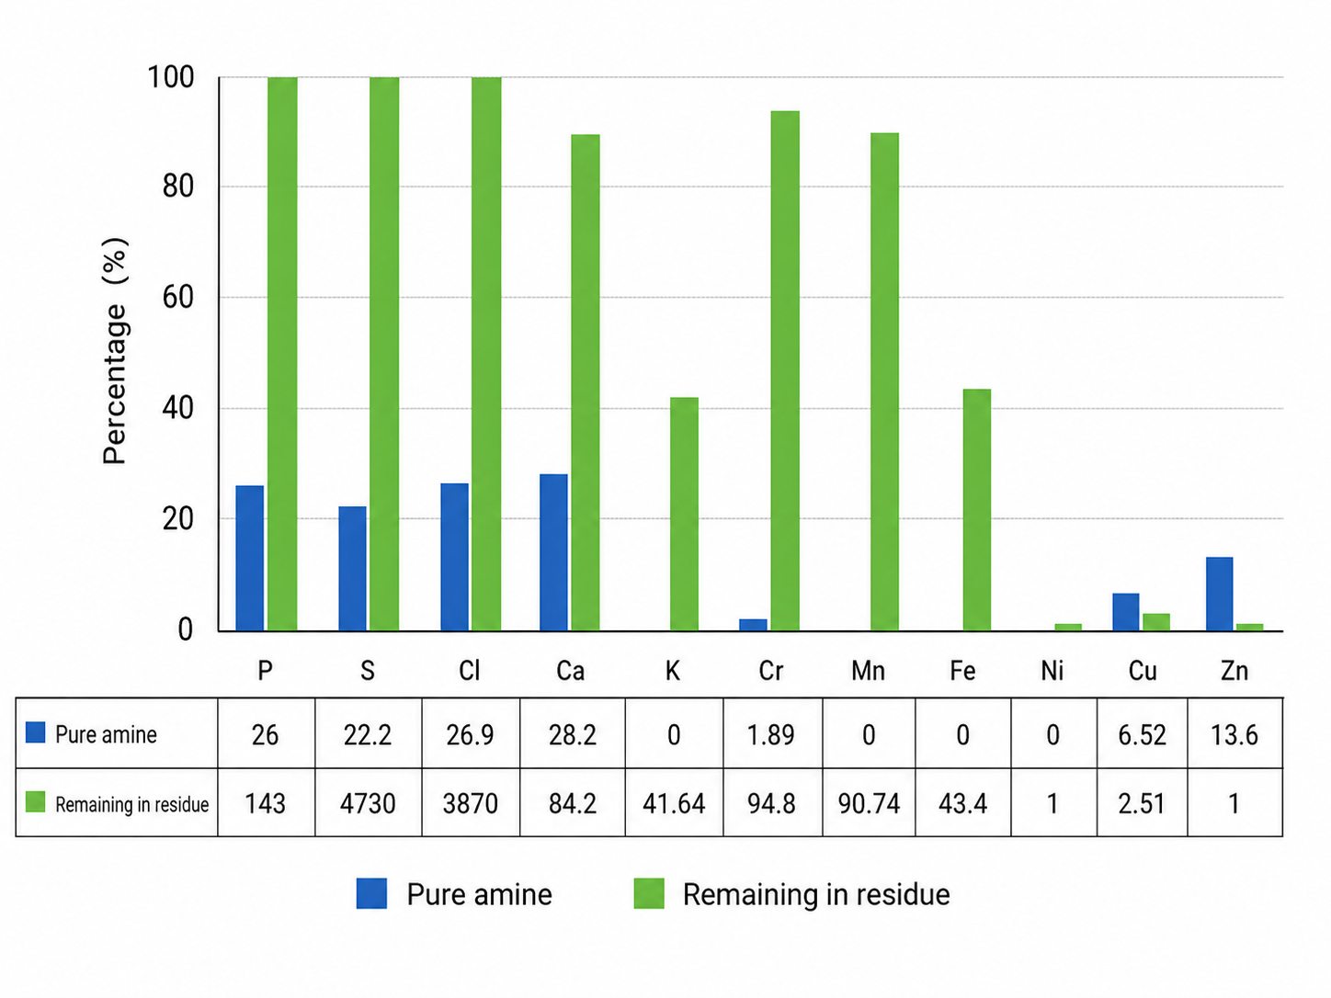
Figure 6. Comparative analysis of heavy metals and industrial waste components in purified amine and still-bottom residue.
The lower Al, Si and Cu levels observed in the spent amine may be associated with redistribution of these elements during long-term circulation, including partial precipitation, deposition on internal equipment surfaces, or transfer into insoluble phases and suspended solids. Their apparent decrease in the liquid phase may therefore reflect phase redistribution rather than complete removal from the system.
These observations demonstrate that the proposed regeneration process not only recovers active amine, but also isolates the major part of the hazardous inorganic load in the residue.
Practical and environmental significance of regeneration
The obtained results show that regeneration of spent MDEA solutions is a rational alternative to complete solvent disposal. The process restores key operating properties of the absorbent, reduces solvent losses, lowers waste discharge, and decreases the environmental risk associated with contaminated spent solvent. These findings are consistent with recent studies emphasizing the importance of sustainable amine management in acid gas removal systems.
Conclusions
Prolonged industrial use of 30 wt.% aqueous methyldiethanolamine in natural gas sweetening leads to significant solvent degradation caused by thermal exposure, oxidative transformations, interaction with acidic gas components, and the accumulation of heat-stable salts, resinous compounds, and metal-containing impurities. These changes reduce the technological efficiency of the absorbent and increase the environmental burden associated with spent solvent disposal.
Regeneration by vacuum distillation followed by liquid-liquid extraction substantially improved solvent quality. Heat-stable salts decreased from 2,218 to 300 ppm, bound amine from 6.85 to 0.20 %, viscosity from 3.6 to 2.78 cP, density from 1.29 to 1.018 g/cm³, and foam height from 1.9 to 1.1 cm. GC-MS analysis confirmed methyldiethanolamine recovery of about 60 % after chloroform extraction and up to 78 % after ethyl acetate extraction. In addition, the regenerated fraction contained considerably lower levels of heavy metals than the still-bottom residue. These findings confirm that the proposed regeneration approach is technically effective, resource-efficient, and environmentally sound for reducing waste discharge and improving the operational performance of natural gas sweetening systems.
Overall, the proposed treatment is a technically effective and environmentally meaningful approach for restoring spent MDEA solutions and improving the sustainability of natural gas sweetening systems.
References
Abotaleb A., Gladich I., Alkhateeb A., Mardini N., Bicer Y., Sinopoli A., 2022, Chemical and physical systems for sour gas removal: An overview from reaction mechanisms to industrial implications, Journal of Natural Gas Science and Engineering, 106, 104755. DOI: 10.1016/j.jngse.2022.104755.
Alekseev S.Z., Afanasyev A.I., Kislenko N.N., Karenov K.D., 1999, Purification of natural gas with ethanolamines from hydrogen sulfide, carbon dioxide and other impurities, Gazprom Information and Research Center, Moscow, Russia (in Russian).
Anvaer B.I., Drugov Yu.S., 1976, Gas chromatography of substances, Khimiya Publishing House, Moscow, Russia (in Russian).
Chew Y.E., Putra Z.A., Foo D.C.Y., 2022, Process simulation and optimisation for acid gas removal system in natural gas processing, Journal of Natural Gas Science and Engineering, 107, 104764. DOI: 10.1016/j.jngse.2022.104764.
Esmaeili A., Yoon T., Atsbha T.A., Lee C.-J., 2023, Rate-based modeling and energy optimization of acid gas removal from natural gas stream using various amine solutions, Process Safety and Environmental Protection, 177, 643–663. DOI: 10.1016/j.psep.2023.07.030.
Etoumi A., Alhanash M., Almabrouk M., Emtir M., 2021, Performance Improvement of Gas Sweetening Units by Using a Blend of MDEA/PZ, Chemical Engineering Transactions, 86, 1057–1062. DOI: 10.3303/CET2186177.
Faqih M., Omar M.B., Wishnuwardana R.J., Ismail N.I., Mohd Zaid M.H., Bingi K., 2024, Prediction of solvent composition for absorption-based acid gas removal unit on gas sweetening process, Molecules, 29(19), 4591. DOI: 10.3390/molecules29194591.
Guo L., Wang B., Wang N., Chen Y., Zhang L., Wang Y., Liang Y., 2021, Optimal Ratio of Methyldiethanolamine and Monoethanolamine Based on Regenerative Energy and Absorption Capacity Analysis, Chemical Engineering Transactions, 88, 1237–1242. DOI: 10.3303/CET2188206.
Igamkulova N.A., Mengliev Sh.Sh., Rakhimov Kh.N., Turaev T.B., Pulatov Kh.L., Sapaev B., 2023, Degradation of ethanolamines and reducing their impact on devices, AIP Conference Proceedings, 2789(1), 060001. DOI: 10.1063/5.0145441.
Igamqulova N., Mengliev Sh., Egamberdiev E., 2023, Reduction of waste disposed to the environment through recycling of unused methyldiethanolamine, E3S Web of Conferences, 371, 01049. DOI: 10.1051/e3sconf/202337101049.
Ivanova L.V., Safieva R.Z., Koshelev V.N., 2008, IR spectroscopy in the analysis of petroleum products, Bulletin of Bashkir University, 13(4), 869–874 (in Russian).
Ivanova L.V., Koshelev V.N., Burov E.A., Stokolos O.A., 2010, Application of IR spectrometry in the study of crude oils, Proceedings of Gubkin Russian State University of Oil and Gas, 2, 76–80 (in Russian).
Mailhol L., Bouallou C., 2021, Kinetic Study of Post Combustion CO₂ Absorption by Methyldiethanolamine 30 wt.% and Hexylamine 10 wt.% as New Aqueous Solution, Chemical Engineering Transactions, 88, 181–186. DOI: 10.3303/CET2188030.
McNair H.M., Bonelli E.J., 1970, Basic gas chromatography, Mir Publishers, Moscow, Russia.
Mohajeri M., Panahi M., Shahsavand A., 2024, Optimal operation of a natural gas sweetening plant, Computers and Chemical Engineering, 184, 108631. DOI: 10.1016/j.compchemeng.2024.108631.
Panahi H., Eslami A., Golozar M.A., 2020, Effect of heat stable acids on corrosion and stress corrosion cracking initiation of 304 and 316 stainless steels in activated methyl diethanol amine solution, Corrosion Engineering, Science and Technology, 55(1), 57–65. DOI: 10.1080/1478422X.2019.1669762.
Shahouni R., Abbasi M., Akrami M., 2024, A comprehensive review on control and mitigating the foam formation in amine-based solvents, Chemical Engineering Journal Advances, 19, 100618. DOI: 10.1016/j.ceja.2024.100618.
Shirokikh S., Kalmykov D., Matveev D., Bazhenov S., 2023, Reclaiming of amine CO₂ solvent using extraction of heat stable salts in liquid-liquid membrane contactor, Membranes, 13(2), 230. DOI: 10.3390/membranes13020230.
Shpeleva L.S., 2011, Development of a rational technology for purification of aqueous diethanolamine solutions during absorption extraction of acidic components from natural gas, PhD Thesis Abstract, Astrakhan, Russia (in Russian).
Turaev T.B., Igamkulova N.A., Mengliyev Sh.Sh., Rakhimov H.N., 2024, Recovery of spent methyldiethanolamines and reduced environmental impact, E3S Web of Conferences, 491, 04010. DOI: 10.1051/e3sconf/202449104010.
Wishnuwardana R.J., Omar M.B., Zabiri H.B., Faqih M., Ismail N.I., Bingi K., 2025, Absorption-based optimization technologies for acid gas removal units: A review of recent trends and challenges, Processes, 13(6), 1909. DOI: 10.3390/pr13061909.
Yehya R., Abou Sharaf N., Riachi B., Assaf J.-C., Hamd W., 2025, A novel integrated simulation approach for natural gas sweetening and dehydration: H₂S, CO₂, and H₂O removal with energy optimization using Aspen HYSYS, Results in Engineering, 28, 107972. DOI: 10.1016/j.rineng.2025.107972.

